_{BARE}
Business Alliance for Renewable Energy

Turkey Energy Build-Up

An executive summary of the proposed project is included as the first page of the budget narrative.

Project Narrative

Established in 1992, the Business Alliance for Renewable Energy (BARE) represents the interests of over 1,000 member companies. The industry these companies compete in includes geothermal, solar, wind, bio-mass, and hydroelectric sources of renewable energy. Some BARE members, especially those involved in electric power transmission and regulation, offer products and services common to both renewable and non-renewable energy sources such as clean coal and nuclear power, but for the most part, BARE members focus uniquely on renewable sources.

With the help of an MDCP award, BARE plans to lead the U.S. renewable energy industry in developing Turkey as an export market for U.S. goods and services.

Demand in Turkey for Renewable Energy and Energy Efficiency (RE/EE)

As both the U.S. Commercial Service (CS) and United Kingdom Trade and Investment (UKTI) point out, Turkey is a vibrant and growing market. Prospects for growth in renewable energy and energy efficiency (RE/EE) are particularly good.

Turkey has undertaken a major RE/EE program. CS reports that the country “aims to increase its clean energy share to 30% of its power supply by 2023 – the 100th anniversary of the Turkish republic.” To help accomplish this, Turkey will invest $40 billion in RE/EE during the eight years 2013-2020 or $5 billion per year. In its report CS goes on to identify “major business development opportunities in solar, wind, geothermal, hydro and all elements of energy efficiency.”

The viability of these particular sectors classified as RE/EE is also the message underscored by UKTI. For example, Turkey will need the entire range of infrastructure to produce wind-based energy, distribute it, and regulate it. By the country’s 2023 centennial, it plans to increase wind power almost twelve fold to 20,000 megawatts (MW). Increase in hydro-electric capacity is projected to be even greater. As UKTI points out “Turkey possesses a significant number of rivers and lakes (with approximately 36,000 MW of energy potential), which offers ideal opportunities for the small and large-scale energy companies.” Geothermal resources to be harnessed are also significant. Turkey ranks 7th in the world in geothermal potential.
Installed power generation capacity in Turkey in megawatts (MW)

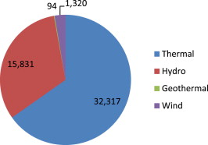

Solar

Turkey’s solar power generation potential is on a scale roughly equivalent to Spain or California. All three are roughly on the same latitude. However unlike California, or especially Spain, Turkey has done relatively little to tap the potential of solar power. This is due, in large part, to the lack of incentives in Turkey. This has begun to change. In December 2010, Turkey introduced a price guarantee of $0.133 per kilowatt-hour for solar energy. This is only 1/6 the price guarantee that Spain provides, but it is enough to entice U.S./Dutch firm GiraSolar to propose a 100-MW photovoltaic power station in southern Turkey. Such solar plants, as opposed to dispersed, mostly rooftop installations as predominate in Germany and elsewhere in Europe, are particularly attractive in Turkey, where sunshine and available land make them a more viable option.

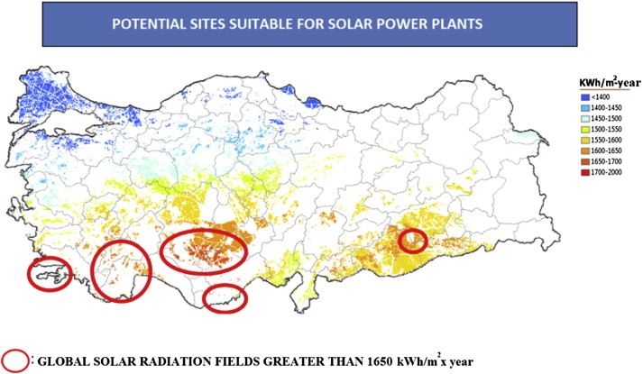
“Potential of renewable energy in electrical energy production and sustainable energy development of Turkey: Performance and policies,”
- Hüseyin Benli

The map above shows areas in Turkey particularly disposed to the development of large solar power plant installations. U.S. solar companies are well placed to compete for such large solar plants, as compared to dispersed rooftop capacity. U.S. companies pioneered solar plants with projects going back to the 1970s and 1980s in the southwestern deserts of the United States.

Frankly, many U.S. solar energy companies are having a tough time. In 2011, publicly traded shares in U.S. solar energy firms dropped 57%. (See “Dark Times Fall on Solar Sector,” New York Times, Dec. 27, 2011.) Competition from China, mostly in the production of solar panels, has been stiff. The bright spot has been solar farms where U.S. firms have a head start on most international competitors. This is particularly true for solar power that does not rely on the photovoltaic cells that China has begun to manufacture so cheaply. Solar power that uses parabolic reflectors to focus solar energy on a molten element is a technology that lends itself only to large-scale plants. Turkey is a prime candidate to host such plants.

Wind

Opportunities for wind power development are significant and U.S. firms may have some advantages. In order for Turkey to increase its wind-generated energy capacity twelve fold by 2023, it will need to have an average annual increase of capacity of between 30 and 40%. It is doubtful that Turkey could possibly achieve such an increase while relying on domestic capacity. In fact, Turkey lacks the research and development, manufacturing, and service capacity to have even achieved what small gains it has heretofore.

Moreover, the majority of wind potential in Turkey is around its coastal periphery where any advantage a Turkey company might have due to overland networks and supplier connections would be nil compared to sea-supported or sea-based development likely to be employed by U.S. firms. As indicated on the map below, most of the opportunities are at the northwest coast on the Aegean Sea, the coasts of the Sea of Marmara, the southwestern coast of the Black Sea, and southern central Turkey near the Mediterranean Sea.
Hüseyin Benli

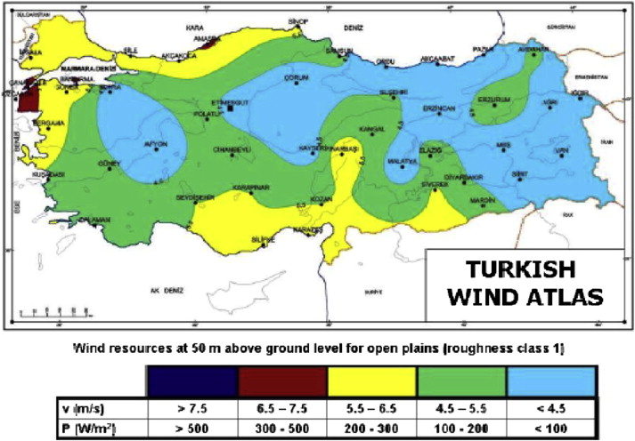
Another advantage the U.S. industry has is idle capacity. As pointed out in a September 21, 2012 article in the New York Times, wind energy employment has slackened in United States in the face of cheap competition from Asia, weak electricity demand, expiring federal tax credits, and cheap natural gas. This means that the excess capacity of the U.S. industry to fulfill demand is great. It also means that U.S. firms will have to be more interested in exporting as a matter of economic survival.

Geothermal

Significant opportunities exist for U.S. firms for geothermal exploration, drilling and geophysical engineering services. While as shown on the pie chart of current energy production, the proportion that comes from geothermal is small, Turkey is committed to fully harnessing this resource.

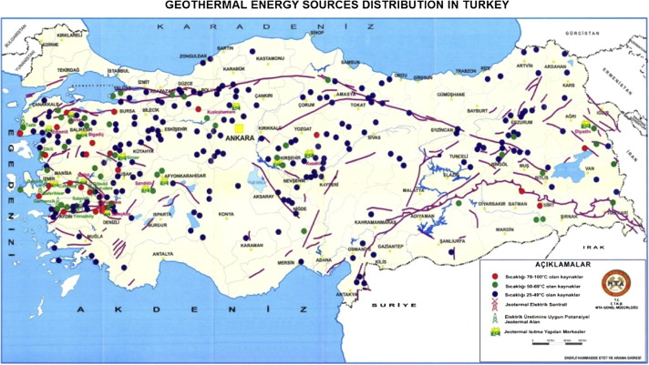
Hüseyin Benli

U.S. firms were some of the earliest to development expertise in harnessing geothermal power generation. Large installations in the western United States have been in operation for decades. Moreover, much of the infrastructure that supports the exploration and exploitation of geothermal power potential is the same infrastructure that supports the oil and gas industry’s exploration and exploitation activities. This would be an advantage for U.S. firms.

Hydro

Exploitation and management of hydro-electric capacity in Turkey is characterized by numerous enterprises, most small or medium-sized. The interests of these firms have been pushed hard by the Erdogan Government, which wants to exploit 100% of Turkey’s hydro potential. A couple of very big projects have proved to be a difficult sell for the government. For example, in 2009 work stopped on Ilisu dam on the Tigris River due to the planned displacement of thousands of residents and the inundation of historical sites. Another project, the Beyhan dam on the Euphrates River would require the forced clearance of villagers, mostly Kurdish, in areas still smarting from war with the Kurdish PKK in the 1980s. Both projects could have been sticking points in relations with downstream states Syria and Iraq. But bilateral regulation has now brought certainty. Such international concerns no longer threaten to derail projects as they once did.

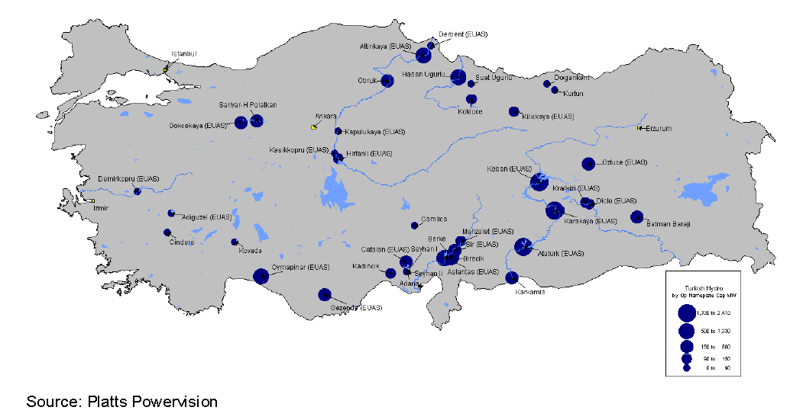

Still, most projects are proceeding or will proceed in order to meet the government’s goal of doubling the current hydro capacity by the 2023 deadline.

Market for RE/EE in Turkey

As shown in the diagram below, the wholesale market for electricity is divided between state-owned TETAS and 69 privately-owned companies. Between them, these account for most of the growing RE/EE-based generating capacity that the government is so strongly encouraging.

While many of the energy companies in Turkey would compete with U.S. firms, most, even those that do compete head-to-head in one realm, are greater potential customers than they are competitors. Here are the major Turkey players in hydropower:
Akenerji Elektrik Uretim A.S. (Akenerji),
Guodian Changyuan Electric Power Co., Ltd.,
Aksa Enerji Uretim A.S., and
Zorlu Enerji Elektrik Uretim A.S.
Given the fast pace of development by 2023 called for in Turkey’s plans, it is unlikely that these or other firms would be able to fill the demand. As noted below, some third-country competitors, especially from Europe, would compete head-to-head with U.S. firms, but others would likely be interested in integrating U.S. products and services in the design, construction, and operation of power plants.

“Hydropower in Turkey: Potential and Market Assessment,” Pöyry Management Consulting (Norway) AS, commissioned by Norwegian Renewable Energy Partners. (http://www.econ.no/stream_file.asp?iEntityId=4732)
Structure of the Turkish Electricity Sector

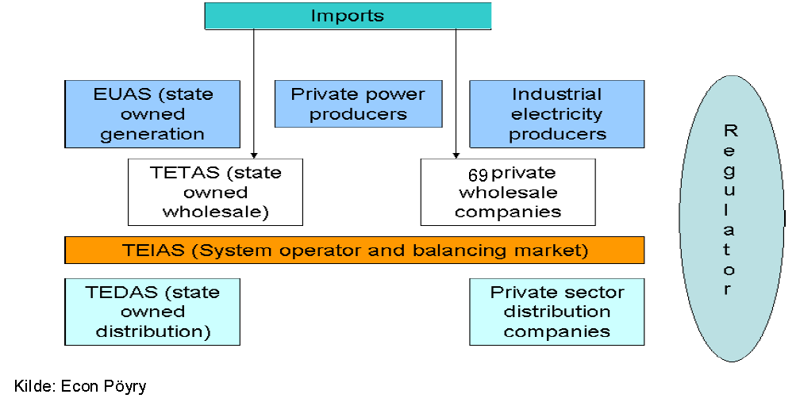

Third-Country Competitors

European firms are the most active foreign RE/EE players in Turkey. These are mostly large firms like A2A SpA, or GDF Suez. These two particular firms, one Italian and one French, are primarily concerned with generating, selling and distributing electricity. Therefore, they do not compete directly with U.S. firms eager to sell RE/EE design services or products. In fact, their core businesses are activities complementary to or require U.S. RE/EE products and services. By contrast, other large European firms like ABB Ltd and Andritz AG do offer products and services that compete with those offered by U.S. firms. These include turn-key hydropower installations.

Work Plan

BARE has a simple strategy for helping U.S. companies export RE/EE products and services to Turkey. This strategy is built around an industry forum one industry forum and one trade show in Turkey and one trade show in Germany/Austria:

Industry Forum

International Energy Congress and Fair /EIF 2014
Ankara, Turkey
24-25 October 2014 (October 2015 and October 2016)
EIF is a platform for addressing a wide range of topics related with energy production in Turkey and all around the World. Organized by Turkey’s Global Energy Association, EIF is an annual event focusing on the latest developments and industry practices. Presenters, including some ministry heads from throughout the region, mingle with EIF participants, who have the option of a small exhibition space. EIF offers its own company match-making service during the event as well.

Trade Fairs

RENEX Eurasia Renewable Energy
Ankara, Turkey
14-17 November 2014 (November 2015 and November 2016)
2014 will be RENEX Eurasia’s fourth year. This trade show focuses on renewable energy and environmental technology. Exhibitors focus on renewable, conventional, energy, power, wind, solar, photovoltaic, hydropower, geothermal, biomass, biogas, biofuel, battery, coal, nuclear, oil, gas, offshore, pipeline, green. Visitors include electricity producers and distributors, fitters, engineers, contractors, architects, technical consultants, building economists, social housing departments, local and regional authorities.

Power Executive Program
POWER-GEN Europe
4-6 June 2014 (June 2015 in Vienna and June 2016 in Cologne)
Cologne, Germany
POWER-GEN Europe is the region's largest event dedicated to power generation. With than 13,000 attendees and 600 exhibitors from over 100 countries this annual fair attracts public and municipal utility owners and managers, plant owners and operators, project developers and managers, independent power producers, investors, traders, and OEMs from throughout the region.

Outreach and Preparation to Participate in Trade Fairs

Within weeks of receiving an MDCP award, BARE will embark on an outreach campaign to secure participation by 100 RE/EE companies in activities designed to prepare U.S. firms to participate in one or more of the trade shows. BARE has already surveyed its members and discovered that 31 are committed now to participating in project activity and another 17 are “interested.” BARE will reach out to non-BARE members in the industry and again to those who did not respond to the earlier questionnaire with the goal of doubling from 48 (31+17) to 100 the number of participating firms. In addition to email invitations, home-page announcements, and a phone campaign targeted at the best prospects for expanding to Turkey, BARE will invite the U.S. Export Assistance Centers (USEACs) located near each U.S. firm in the industry to coordinate efforts to get them to participate.

Annual Turkey Overviews

BARE holds its annual meeting each year in mid-January and has the tradition of several 90-minute workshops available to participating companies. Each year of the project, BARE will have a workshop devoted to preparing to enter the Turkey RE/EE market. These workshops will include primers on: the market, business customs, export financing, the three fairs, special benefits available thanks to the MDCP award, and Commercial Service and other ITA services. BARE will invite the leader of the ITA-MDCP project team as well as Turkey-based Commercial Officers and locally engaged staff of the Commercial Service such as Serdar Cetinkaya to present.

Pre-Fair Seminars

There are two fairs and one forum each year of the three year project. Four to five months prior to each fair, BARE will hold a webinar. So, over the three-year project, there will be nine fairs. Content will be based on the annual overviews but will focus more closely on just one upcoming fair. I&A industry specialist(s), Turkey-based Commercial Officers, and locally engaged staff of the Commercial Service such as Serdar Cetinkaya will be invited to participate/present during these webinars. Export finance experts, such as representatives from local Small Business Administration and Export-Import Bank, will be invited to participate as well.

Pre-Fair One-on-One

BARE will coordinate with each interested firm’s local USEAC so that within one month of the pre-fair seminars, they reach out together to firms that have registered interest in participating in the trade fairs. These outreach calls will be individualized. Interested firms will be asked if they have all of the elements in place to be ready for the show, e.g. relations with logistics firms that can facilitate exports, export financing, etc. Each firm will be reminded of the need to report export successes.

Trade Fair Participation

The most significant financial benefit that BARE offers its members is a trade fair participation package that essentially reduces the amount that a BARE member would pay by $2,000. For companies that are not BARE members, the reduction would $500 less than what they would otherwise pay. This benefit is limited to firms with 500 employees or less. Details are set forth in the Success Agreement.

Post-Fair Follow Up

BARE will coordinate with each participating firm’s local USEAC so that within one month of the trade fair, they: offer help following up with trade leads, offer services such as Gold Key or International Partner Search that may help the company take next steps, ask the firm to report exports generated by their participation in the trade fair.

Performance Measurement

Exports to be generated by the project are calculated and presented in the budget narrative. Project specific milestones are:
- Number of firms participating in each trade show: goal 20.
- Number of trade shows for which BARE recruits a delegation: Goal 6.

Participation in the Project by U.S. Companies

BARE has shared a summary of its MDCP project idea with its members to determine the level of interest. The table below is a summary of the companies that expressed some level of interest. Key U.S. RE/EE firms are listed in the table below. Note that several of these firms have already declared to BARE their intention to participate in the project if it receives MDCP funding:
Resumes of Key Personnel

BARE Executive Director, Constance Inopal, CAE

Ms. Inopal has directed BARE since 2001. Prior to coming to BARE as executive director she was an account executive for Zephyr Industries, a manufacturer of wind turbine components. Ms. Inopal has been a certified association executive (CAE) since 2006. She has a bachelor of business administration degree from Cornell University and an MBA from Syracuse University. She also serves on the marketing committee of the American Society of Association Executives.

BARE, Marketing Manager, Wendy Whittle

Ms. Whittle came to BARE from the advertising firm Wilson and Sonren of Cleveland. From 1997 to 2002 she serviced several accounts, including several fastener companies. She has a bachelor of business administration with an emphasis in marketing from Ohio State University. Ms. Whittle is fluent in Spanish and French. Since coming to BARE in 2002, Ms. Whittle has increased BARE membership 14% despite several consolidations in the industry.

BARE Outreach Director, Istvan Bull, CAE

Mr. Bull has held his current position since 2007. Prior to serving as executive director, he was BARE’s marketing manager, a position he held beginning in 2004. Prior to that Mr. Bull was director of member services and event management at the Sheet Metal Manufacturers Institute. (SMMI). In addition to a bachelor degree in Spanish and a master of international management from Thunderbird. Mr. Bull recently coordinated the opening of an office in Mexico City. From this office, 27 BARE members have established agent or distributor relationships in Mexico, Costa Rica, and Colombia. He is fluent in Spanish.

Company interest in Turkey project
The more companies you can show are willing to participate, the better. Showing information about the industry and demonstrating who supports you increases the likelihood that we will fund your project.

Company | Sector | Notes | MDCP project
[Acme Hydro]  [Tacoma, WA] | Hydro | Consulting engineering and systems development | Committed to participate
[Alpha Environmental]  [Moscow, ID] | Hydro | Hydro consulting services | Committed to participate
[Benstein & Behl]  [Hawthorne, NV] | Geothermal,  Wind | Parts and power interface for power plants | Committed to participate
[Beterave, Ltd]  [Beetville, IL] | Wind | Manufactures grid-connected large wind turbines | Committed to participate
[Bluebird Manufacturing]  [Cleveland, OH] | Biomass, Geothermal, Solar,  Wind | Engineering, scientific, systems integration, and technical solutions and services | Committed to participate
[BMR, Inc.]  [Ipswich, OK] | Biomass, Solar,  Wind | Design, construction and maintenance services | Committed to participate
[Brightsource Energy]  [Oakland, CA] | Solar | Designs, builds, finances, and operates utility-scale solar power plants | Committed to participate
[Cantrell Industries]  [Palm Springs, CA] | Solar | Designs and integrates large-scale solar collection and power generation systems | Committed to participate
[Capitol Systems]  [Vancouver, WA] | Hydro, Wind | Forecasting and planning services | Committed to participate
[Cardinal Ltd ]  [Cleveland, OH] | Biomass, Geothermal, Solar, Wind | System integration, and technical solutions and services | Committed to participate
[Cowton International Corp.]  [Golden, CO] | Geothermal, Hydro, Wind | Develops and builds power plants | Committed to participate
[Earth and Sun, Inc.]  [Reno, NV] | Geothermal, Solar,  Wind | Training, maintenance, and technical support for utility-scale projects | Committed to participate
[Econergy Intl.]  [Boulder, CO] | Biomass, Hydro, Wind | Develops and builds power plants | Committed to participate
[Earth [Flowserve Corporation]  [Irving, TX] | Hydro | Flow control equipment (pumps, valves and seals), aftermarket parts, engineering, tech services, education, training | Committed to participate
[Greene and Greene]  [Richmond, VA] | Biomass,  Geothermal, Solar,  Wind | Provides engineering, scientific, systems integration, and technical solutions and services | Committed to participate
[Kelster, Inc.]  [San Bernadino, CA] | Solar | Manufactures custom structural supports for solar generation systems | Committed to participate
[New Green Technologies]  [Tampa, FL] | Biomass, Solar, Wind | Develops green energy and bio-fuels projects. | Committed to participate
[Sharpe Systems]  [Phoenix, AZ] | Solar | Manufactures and services infrastructure for solar plants using parabolic dishes | Committed to participate
[Sledston Partners Ltd]  [Hudson, CA] | Geothermal | Instrumentation, monitoring and testing | Committed to participate
[Solar Reserve]  [Santa Monica, CA] | Solar | Develops utility-scale concentrating solar power plants | Committed to participate
[Sun Edison]  [Beltsville, MD] | Solar | Provides monitoring, marketing, standards, and solar tariff services | Committed to participate
[Sun Power]  [San Jose, CA] | Solar | Designs and manufactures cells, roof tiles and, panels | Committed to participate
[Suzlon Energy Ltd]  [Chicago, IL] | Wind | Manufactures grid-connected large wind turbines | Committed to participate
[Zebra Energy Ltd]  [Batavia, IL] | Wind | Manufactures grid-connected large wind turbines | Committed to participate
[Benson & Jacobs]  [Knoxville, TN]  If we fund your MDCP project we will post your application at trade.gov/mdcp. Bracket any information you wish not to disclose so that you can redact it if you get an award. | Hydro, Wind | Parts and power interface for wind and hydro turbines | Interested
[Beta Ltd.]  [Knoxville, TN] | Hydro | Aftermarket parts, training, consulting | Interested
[Deep Energy Systems]  [Rexburg, ID] | Geothermal, Hydro, Solar, Wind | Designs, builds, integrates distributed power systems | Interested
[Earth and Sun, Inc.]  [Henderson, NV] | Geothermal, Hydro, Solar, Wind | Develops utility-scale wind, geothermal, Hydro and solar generation | Interested
[Green Power Partners]  [St. Petersburg, FL] | Biomass, Solar, Wind | Develops green energy and bio-fuels projects. | Interested
[Heissman, Inc.]  [Canton, OH] | Solar, Wind | Designs and manufactures components for wind turbines and solar plants | Interested
[ICM, Inc.]  [Colwich, KS] | Biomass, Solar, Wind | Design, construction and maintenance services | Interested
[Keller, Inc.]  [Freeton, OH] | Solar, Wind | Designs and manufactures components for wind turbines and solar plants | Interested
[Sigma Industries]  [Savannah, GA] | Biomass, Hydro,  Solar, Wind | Power generation system design and build | Interested
[SolCo]  [Frederick MD] | Solar | Provides monitoring, marketing, standards, and solar tariff services | Interested
[Stirling Energy Systems]  [Scottsdale, AZ] | Solar | Develops equipment for generating systems using parabolic dishes | Interested
[Terra-Gen Power]  [Reno, NV] | Geothermal, Solar,  Wind | Develops utility-scale wind, geothermal, and solar generation | Interested

Example of Proposed Use of ITA Emblem:
This shows your intent to credit ITA. We need an example of intended use in order to grant you permission to use the emblem in the event that you win an MDCP award.
BARE-online.org/international

Business Alliance for Renewable Energy-BARE
International

Foreign buyers  Reverse trade mission schedule  Visitors to past U.S. shows  Visitors registered for upcoming shows | Market research  Quick survey of global renewable energy markets  Sources for foreign market research  What to consider before going abroad |  | Turkey Energy Build-Up  Fed. award spurs project  Upcoming trade fairs  Prepare now to export  The market  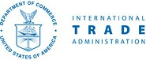
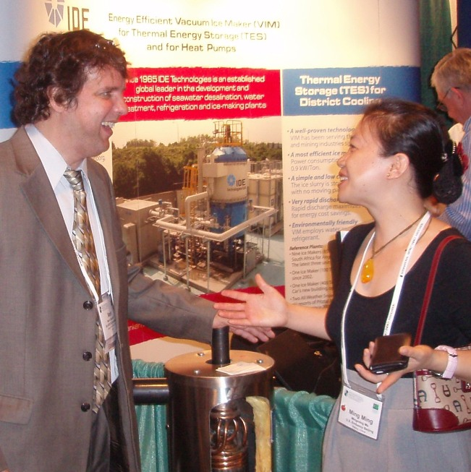 |  | Over 90% of exhibitors and attendees at RenewTech voted it the best trade show of the year. Exhibitors were pleased that attendees were almost all potential customers. The hospitality booths are arranged to benefit all exhibitors.  Sponsors below helped make the show a great success.  Quality  Systems  Risk *  Jones  Acme Inc.

Turkey Energy Build-Up
Companies that participate in your project activities need to:
- See benefits of participating
- Commit to report exports
- Affirm that product sold is 51% or more US content
Success Agreement

BARE has identified Turkey as the best new market for many of our members. We want to help you to capitalize on opportunities to develop new export clients in this promising market. The U.S. Commerce Department’s International Trade Administration (ITA) has agreed to pay for one-third of the project cost through its Market Development Cooperator Program (MDCP).

Agreement to Participate in BARE’s Turkey Energy Build-Up (TEBU) Initiative

Please note that some of the benefits listed below are contingent on when you sign up to participate. We will assign time-sensitive benefits in the order that we receive completed participation agreements.

1. Benefits
Thanks to the MDCP award and the partnership with ITA, the following benefits are available to Turkey Energy Build-Up participants. Please indicate which event(s) you plan to attend:
In this example the applicant lists all of the activities proposed during the project period. It may make more sense to have a separate success agreement for each project activity. You can just choose the success agreement you propose to present for your first activity to show here as an example.
Trade Fairs
RENEX Eurasia Renewable Energy, Ankara, Turkey
2014 November 14-17
2015 November 15-18
2016 November 13-16
Power Executive Program, POWER-GEN Europe
2014 June 4-6, Cologne, Germany
2015 June 5-7 , Vienna, Austria
2016 June 9-10, Cologne, Germany

a. Reduction of $2,000 in trade fair fees.
Pay a non-refundable $500 deposit two months prior to any of the trade fairs identified above save big. Your TEBU fees will be $1,750 less than if you arrange to participate outside of TEBU. Limit of one per company.

b. One free Gold Key Service from ITA’s Commercial Service in Turkey.
This includes up to five targeted appointments, an interpreter, transportation, and help with follow-up from ITA. This valuable service is worth hundreds of dollars. It is only available to the first ten companies that sign up to participate in a trade fair. While TEBU will include six trade fairs, there will be only ten free Gold Keys offered per trade show.

c. Translation of product material.
We’ll pay to translate to Turkish the equivalent of a one-page, double-sided brochure for the first twenty companies with fewer than 500 employees to sign up for each trade fair.

d. Pre-trade fair webinar.
Three to four months prior to each trade fair, we’ll host a webinar to include a summary of market conditions, tips on how to do business, export financing, etc.

e. One-on-one counseling session before the trade fair.
After the webinar, ITA will help us to follow up with you as you prepare for the show.

f. Turkish website development.
Every Turkey Energy Build-Up participant that does not already have a Turkish website will get help developing a web presence in Turkish.
Commitment to report exports must be part of any success agreement.

g. Business cards.
We’ll translate into Turkish, business cards for at least one of your employees.

2. Reporting your success.
Our partner, ITA, needs to be able to show that its financial assistance to BARE is a worthwhile investment of U.S. tax dollars. So, as a condition of benefiting from this project, you agree to report as set forth below.

a. Photographs and video.
ITA or BARE may arrange to take photographs or shoot video of project activity. ITA and BARE will use such media to promote the project, to describe what progress has been made generally, and to promote MDCP generally in the association and non-profit community. ITA will abide by 2.d. below if it seeks to highlight a particular success.

b. Sharing export results with ITA.
Each quarter, as a TEBU participant, you report to BARE the destination market, value, and brief description of each export and/or export-related developments that are generated, in whole or in part, by participating in TEBU. If you prefer not to report this information to BARE, you may report it to an ITA official, who will not, in such case, divulge details of such individual sales to BARE.

c. Confidentiality with ITA.
ITA does not share your submitted export information publicly unless you specifically authorize it to do so. ITA professionals who have access to your success information have security clearances. They are accustomed to handling classified diplomatic cables and other media and transmissions that contain sensitive information.

d. Public highlighting of your successes.
If ITA wants to publicize any of your successes, it will always show you what it proposes to do and secure your express approval in writing.
Use this language word-for-word.

3. U.S. product or service.
I certify that I am, that my company is, or that I or my company represents: (a) a United States citizen; (b) a corporation, partnership or other association created under the laws of the United States or of any State; or (c) a foreign corporation, partnership, or other association, more than 95 percent of which is owned by persons described in (a) and (b) above; AND I am, my company is, or the entity I or my company represents is, exporting, or seeks to export goods or services produced in the United States, or goods or services that contain at least 51 percent U.S. content.
I understand that this certification is a requirement to participate in the MDCP project activity described above and that an intentionally false certification may result in termination of participation in such activity.
Information provided to the International Trade Administration (ITA) is intended solely for internal use. ITA will protect business confidential information to the full extent permitted by law and Administration policy. U.S. law prohibits U.S. government employees from disclosing trade secrets

I agree to the terms of the success agreement with BARE as set forth above.

_______________________________________
Company name
_______________________________________
Email/Phone
_______________________________________
Address
_______________________________________
Name
_______________________________________
Title
_______________________________________ _______________
Signature Date

See Spotlight on Turkey: U.S. Business Opportunities in Renewable Energy and Energy Efficiency into 2014, Michael Lally and A. Serdar Cetinkaya U.S. Embassy Commercial Service (CS) Ankara, Turkey (Export.gov) and Sector Report: Power and Renewable Energy: Turkey, UK Trade & Investment (UKTI), March 2009 (http://static.globaltrade.net/files/pdf/20100922101900.pdf).
Hüseyin Benli, Department of Technical and Vocational Education, Fırat University, TR-23119 Elazığ, Turkey, (http://www.sciencedirect.com/science/article/pii/S0960148112004028) (Hereinafter: Hüseyin Benli)
The Guardian, Fiachra Gibbons and Lucas Moore, Sunday 29 May 2011.
Energy Business Review (EBR)
See http://hydro.energy-business-review.com/companies
This page contains proprietary information, identified between brackets [ ], the release of which would cause competitive harm to BARE.
This page contains proprietary information, identified between brackets [ ], the release of which would cause competitive harm to BARE.
This page contains proprietary information, identified between brackets [ ], the release of which would cause competitive harm to BARE.

