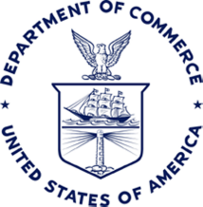

The Manufacturing Council
September 29, 2011
9:00 a.m. – 11:00 a.m. (EDT)
U.S. Department of Commerce

Agenda

Welcome
Joe Anderson, Chair

Economic Update & American Jobs Act Briefing
Dr. Rebecca Blank, Acting Secretary of Commerce

Advanced Manufacturing Briefing
Michael Molnar, Chief Manufacturing Officer, U.S. Department of Commerce

National Export Initiative Update
Francisco Sánchez, Under Secretary of Commerce for International Trade

Agency Briefings
Nicole Lamb-Hale, Assistant Secretary of Commerce for Manufacturing and Services
- Jordan Barab, Deputy Assistant Secretary of Labor, Occupational Safety and Health Administration
- Nancy Cleeland, Director of Public Affairs, National Labor Relations Board
- Dr. William Spriggs, Assistant Secretary for Policy, U.S. Department of Labor
- Don Graves, Executive Director, President’s Council on Jobs & Competitiveness
- Peter Weeks, Clean Energy Advisor, U.S. Department of Energy

Discussion of Next Steps
Joe Anderson, Chair
Chandra Brown, Vice-Chair

Closing Remarks
Peter Perez, Deputy Assistant Secretary for Manufacturing

Adjournment

