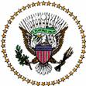

PRESIDENT’S ADVISORY COUNCIL ON

DOING BUSINESS IN AFRICA

Agenda

November 19, 2015

10:00 am – 10:30 am

Washington, DC

- Opening Remarks

- U.S. – Africa Infrastructure Center Discussion

- Consideration of Recommendation Report

- Adjournment

